Marketing Information
Course Description
Providing a lifesaving first aid response in a remote or isolated site where medical assistance may be delayed or evacuation is required, requires specific instruction and practical training.
The course teaches preparation for first aid emergencies based on the site and in line with legal and workplace requirements, Australian Resuscitation Council guidelines and other Australian national peak clinical bodies.
You will learn to assess a casualty, providing safety, contacting and relaying initial and concise information to assist emergency services to your location, undertaking triage for multiple casualties and providing ongoing care.
Instruction on basic first aid and CPR will be provided, as well as treatments specific to remote conditions, such as hypothermia or hyperthermia, head, neck and spinal injuries, using tourniquets and haemostatic dressings for life-threatening bleeding, and managing a casualty in shock.
The course covers completing incident documentation and debriefing, recognising areas for improvement, psychological impacts, the potential need for stress management and support, and seeking help as required.
Provider of Training and Assessment
This course is delivered and assessed on behalf of Allens Training Pty Ltd RTO 90909 by Frontline-Care Comes First
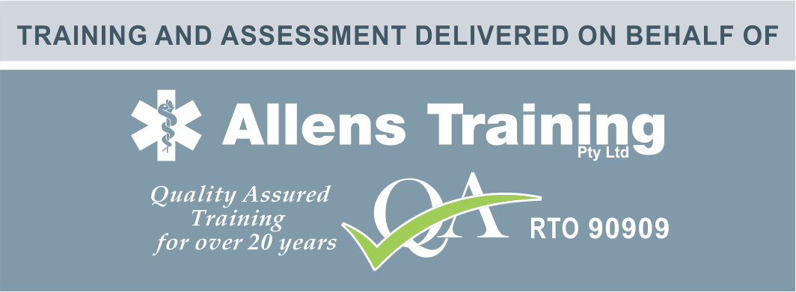
Units Being Delivered
The following units will be included in your certificate:
- HLTAID013 - Provide First Aid in remote or isolated site
- HLTAID009 - Provide cardiopulmonary resuscitation
- HLTAID011 - Provide First Aid
- HLTAID010 - Provide basic emergency life support
Course Delivery
This course can be delivered/assessed in the workplace or at facility organised by the training provider.
Entry Requirements
Participants must have the physical capacity to perform the practical demonstrations, such as 2 minutes of uninterrupted CPR on the floor and performing rescue breathing techniques on manikins.
Online study: Students must have access to a computer, smartphone, tablet or other electronic devices with access to the internet to complete the online/ pre-course studies.
Course Duration
Refresher min. duration | N/A
Blended min. duration | N/A
Face-to-face min. duration | 960 minutes
Online with face-to-face min. duration | 360 minutes
Assessment Requirements
Individuals undertaking this course will be expected to complete both written and practical assessment tasks.
Certificate Renewal Requirements
This certificate has an industry recommended renewal period of 36 months
Learning Rights, Responsibilities and Support, including Complaints
Please note that enrolment to this course is made with Allens Training Pty Ltd RTO 90909. Please refer to the student handbook located on the RTO website allenstraining.com.au (https://allenstraining.com.au/students/student-handbook) for all details relating to rights and responsibilities including complaints and appeals.
Assessment Activities
Practical scenarios and performance tasks:
- Perform CPR on an adult (incl. the use of an AED and placing a casualty into the recovery position)
- Complete a first aid incident report form based on the simulated first aid scenario
- Perform CPR on an infant
- Manage a casualty with anaphylaxis
- Manage a casualty with asthma
- Manage a choking casualty
- Manage a casualty with non-life-threatening bleeding and shock, requiring minor wound cleaning
- Manage a casualty with a nosebleed
- Manage a casualty with a fracture and dislocation
- Manage a casualty with a sprain and strain
- Manage a casualty with envenomation (snake/ funnel-web spider bite)
- Manage a casualty with hyperthermia
- Simulated scenario – First aid response in a remote site (plan and prepare for a remote trip, conduct a basic triage, coordinate an evacuation)
- Complete a planning and equipment checklist
Theory assessment: A written assessment consisting of multiple-choice and short answer questions.

